Hala Ahmed Saad.
Manar Ahmed Mohamed.
Marwan Abdel Hamid Mohamed.
Mustafa Mahmoud Mohammed Jaber.
Mostafa yasser mostafa.

Library Management System

Under supervision
Dr/ Tarek el-shishtawy
Dr/ shaimaa talaat

Table of Contents

1. Abstract 3
2. Introduction 4
3. The objective of the Project 5
4. UML design 6
4.1 Use Case Diagram 8
4.2 Activity Diagram 10
1.2.1 Log in 11
1.2.2 Add book 12
1.2.3 Remove book 14
1.2.4 Add client 15
1.2.5 Remove client 17
1.2.6 Inquire book 18
1.2.7 Read book 19
1.2.8 Borrow book 20
1.2.9 Return book 22
4.3 State Diagram 23
4.4 Sequence Diagram 27
4.5 Class Diagram 31
4.6 Data Flow Diagram (DFD) 33
5. Conclusion 37

Abstract

The Library Management System is gaining more importance as the number of its users are increasing rapidly. As the number is rising there is a need of effective management of library, one such effective system is our Library Management System.
The transactions like login, register, add, remove, delete, borrow, return, search, and read.
The Library Management System stores the details like name, address, ID number, Email and password of users who come to library if they are members. If user is guest, the library system stores his name and ID national.
The details of books like book title, book ID, the total number of pages, the rate, subject to which it belongs author, year of publication etc. are also stored.
There are two modules in our system.
The modules are:
- Admin
- User
Admin Module
The Admin module stores the details of new member, the details of books, updates the status of books, adds newly purchased book details to the database, issues the books, collects fine etc.
User Module
User Module is further classified into two because in our system the user may be a guest or a member.
The users have the functionalities like accessing the books, search for a book etc.

The Library Management System provides exact information about the number of books that are taken by the users, the number of books that are left.

Introduction

Library management system is all about organizing, managing the library and library-oriented tasks. It also involves maintaining the database of entering new books and the record of books that have been retrieved or issued, with their respective dates.

The main aim of this project is providing an easy to handle and automated library management system. This project also provides features and interface for maintaining librarian’s records, student’s history of issue and fines.

The owner can easily update, delete and insert data in the database with this project.

This project has many features like user login and guest login facilities. On top of all this too, there is an administrator (librarian) who manages the authorization and authentication of the entire app, no hacker can log in and modify data, as admin (librarian) login is also available.

Overall, the project of ours is being developed to help the students as well as staff of library to maintain the library in the best way possible and reduce the human efforts. With this computerized system there will be no loss of book record or member record which generally happens when a non-computerized

All these modules are able to help librarian to manage the library with more convenience and in a more efficient way as compared to library systems, which are not computerized.

The objective of the Project

The objective of the Project on Library Management System:
The main objective of the Project on Library Management System is to manage the details of Student, Books, Issues, Librarian, and Member. It manages all the information about Student, Address, Member, and Student. The project is totally built at administrative end and thus only the administrator is guaranteed the access.
The purpose of the project is to build an application program to reduce the manual work for managing the Student, Books, Address, and Issues. It tracks all the details about the Issues, Librarian, and Member.

Functionalities provided by Library Management System are as follows:
- Provides the searching facilities based on various factors. Such as Student, Issues, Librarian,
- Member Library Management System also manage the Address details online for Librarian details, Member details, Student.
- It tracks all the information of Books, Address, and Librarian etc.
- Manage the information of Books.
- Shows the information and description of the Student, Issues.
- To increase efficiency of managing the Student, Books.
- It deals with monitoring the information and transactions of Librarian.
- Manage the information of Student.
- Editing, adding and updating of Records is improved which results in proper resource management of Student data.
- Manage the information of librarian.
- Integration of all records of member.

UML design

UML stands for “Unified Modeling Language”. It is a rich language to model software solutions, application structures, system behavior and business processes. There are 14 UML diagram types to help you model these behaviors.

List of UML Diagram Types
There are two main categories; structure diagrams and behavioral diagrams. Click on the links to learn more about a specific diagram type.
Structure Diagrams
- Class Diagram
- Component Diagram
- Deployment Diagram
- Object Diagram
- Package Diagram
- Profile Diagram
- Composite Structure Diagram
Behavioral Diagrams
- Use Case Diagram
- Activity Diagram
- State Machine Diagram
- Sequence Diagram
- Communication Diagram
- Interaction Overview Diagram
- Timing Diagram
Here we will show only six diagrams out of 14. Six diagrams are:
- Use Case Diagram
- Activity Diagram
- State Machine Diagram
- Sequence Diagram
- Class Diagram
- Data Flow Diagram (DFD)

Use Case Diagram

At first we will explain the diagrams so "At User Diagram " we have 3 users in our project and each one have his activities which would be explained soon, the 3 users are :-
- Client
- Guest
- Admin
Therefore, Clients have some activities "functions" like inquire, Borrow books, Return books, Read books and each one of all activities in details would be shown after user diagram.
Guests have also some activities like Inquire for book, Read books they have less activities because they are not our clients so they have less actions than our clients do.
Admin Category , the admin who have the whole control of the program so he have the most powerful activities like Add client, Remove clients ,Add books , Remove books .

All the 3 users of the program have a common activity "function" such as "Log In" ,"Log Out" and all the activities have to pass from the Validation step ,the first thing that the program does is to show a massage to Welcome the User to the program .

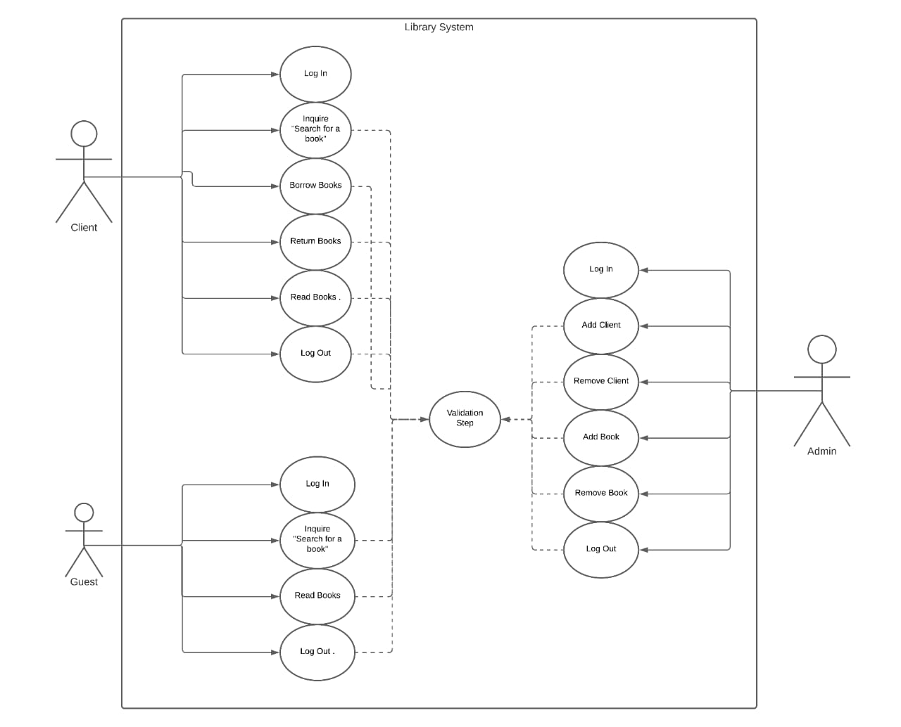

Activity Diagram

In this diagram, we should first now what is the meaning of it and when it use:

Activity Diagrams describe how activities are coordinated to provide a service, which can be at different levels of abstraction.

In particular, use cases where activities may overlap and require coordination. It is also suitable for modeling how a collection of use cases coordinates to represent business workflows:
- Identify candidate use cases, through the examination of business workflows
- Identify pre- and post-conditions (the context) for use cases
- Model workflows between/within use cases
- Model complex workflows in operations on objects
- Model in detail complex activities in a high level activity Diagram
After we know the definition and when we use activity diagram, we will compare this with our project, in our project we make 10-activity diagram that contain all use case:
- Log in
- Add book
- Remove book
- Add client
- Remove client
- Inquire book
- Read book
- Borrow book
- Return book

Log in

Log in is the first state in activity diagram and it explain itself
- Enter user name and password
- Check them if they correct then user log in successfully else
- Return to stage one and return enter user name and password
- Finally display settings
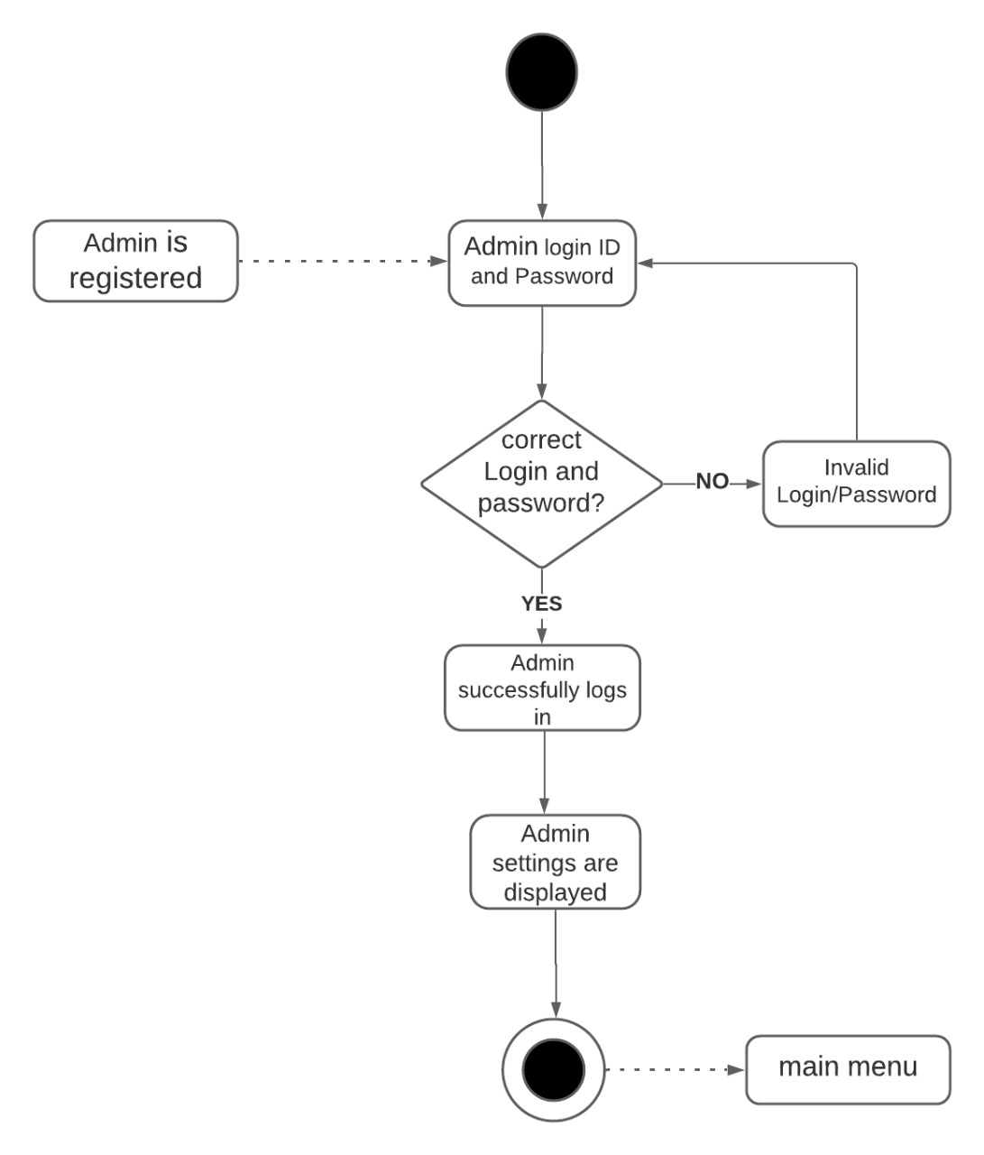

Add book

Second activity is add book and it work as:
- Choose add book from setting
- Enter id of book and check it if id is available then continue
- Else return to previous step
- Then enter title book
- Enter name of author
- Enter number of total pages
- Enter other information about book as in activity diagram of add book
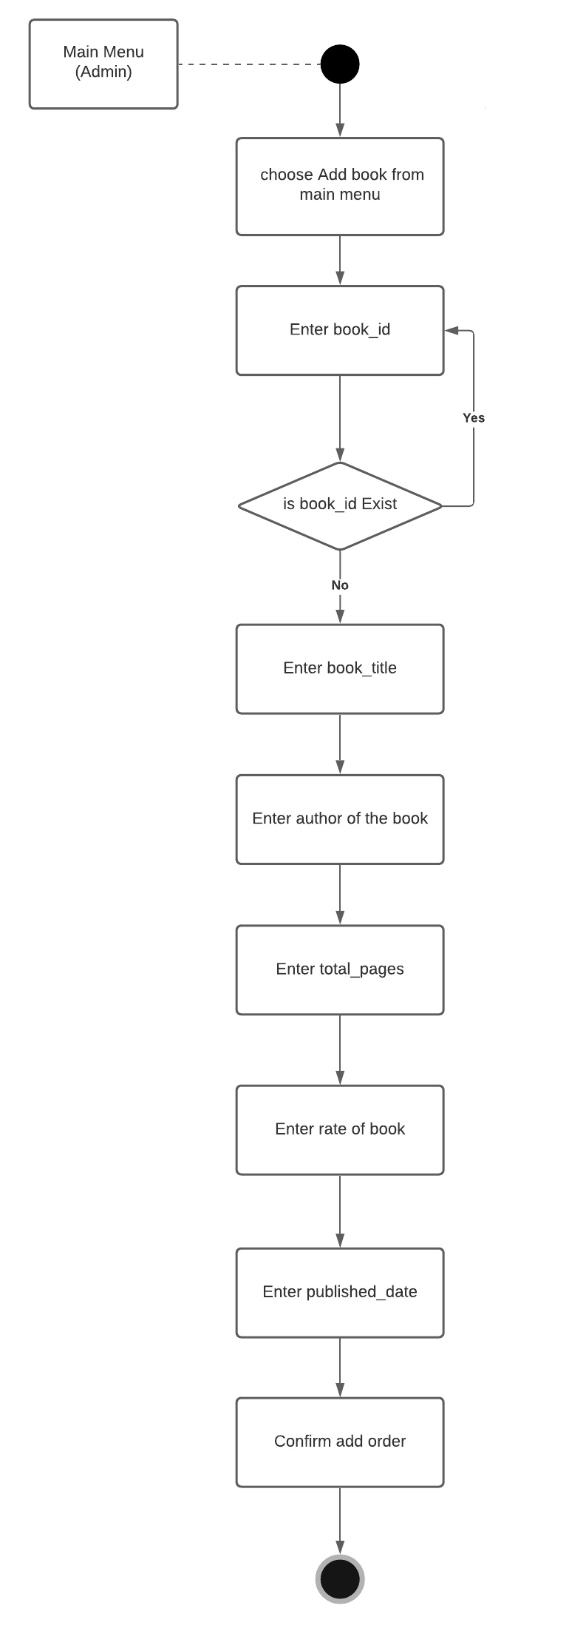

Remove book

Third activity is remove book and it work as:
- Choose remove book from setting
- Enter id of book and check it if id is available then continue
- Else return to previous step
- Then confirm remove order
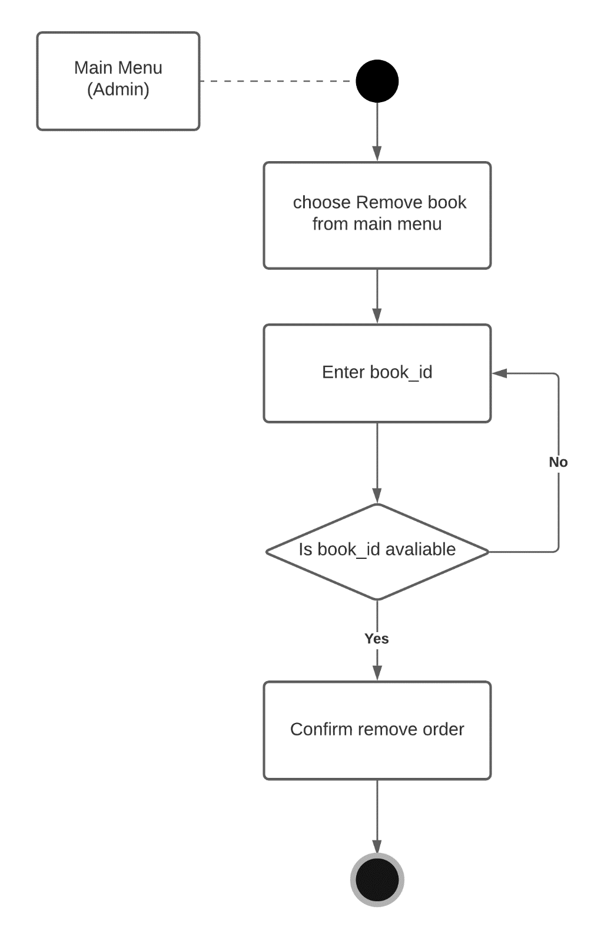

Add client

Fourth activity is add book and it work as:
- Choose add client from setting
- Enter id of client and check it if id is available then continue
- Else return to previous step
- Then enter name of client
- Enter email of client
- check it if email is exist then continue
- Else return to previous step
- Enter password
- Confirm add order
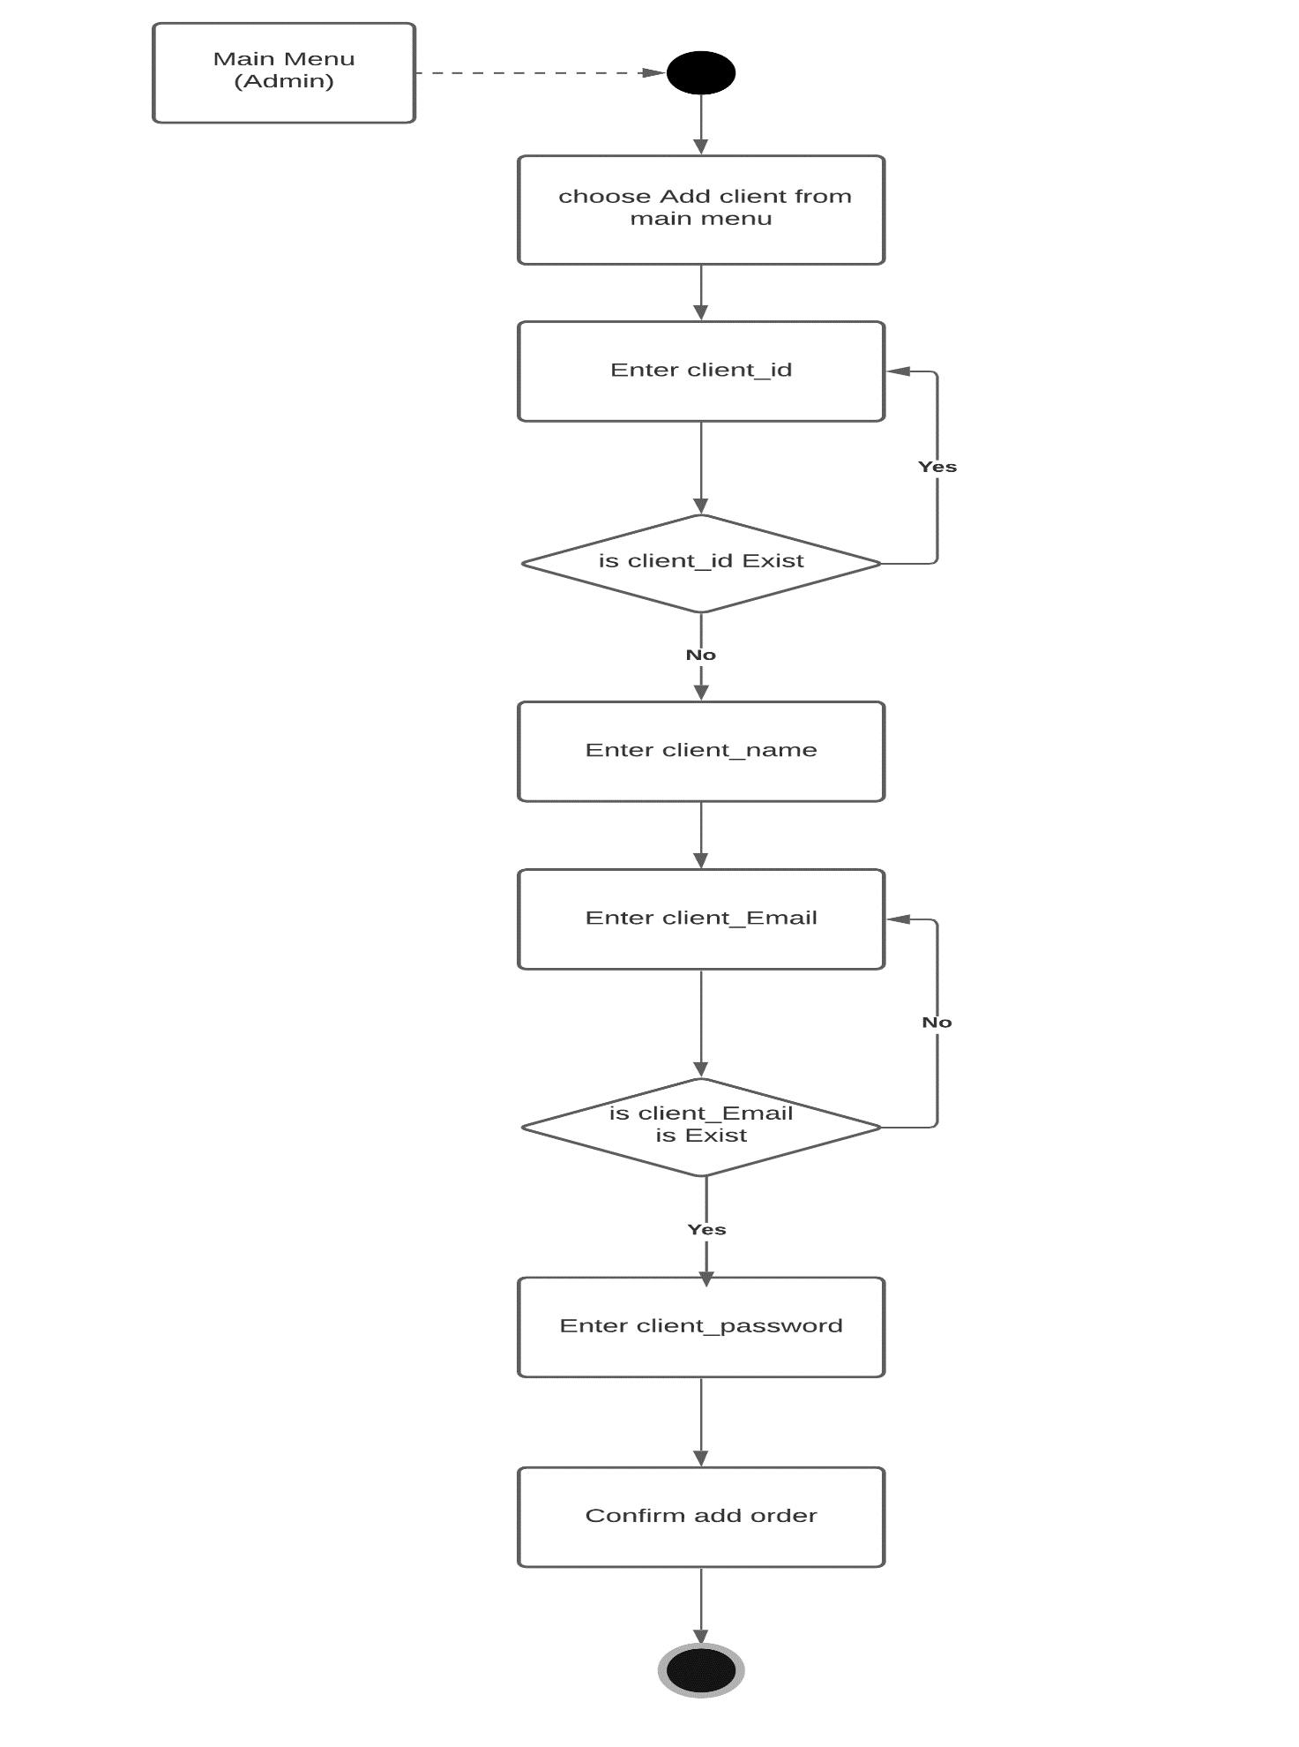

Remove client

Fifth activity is remove client and it work as:
- Choose remove client from setting
- Enter id of client and check it if id is available then continue
- Else return to previous step
- Then confirm remove order
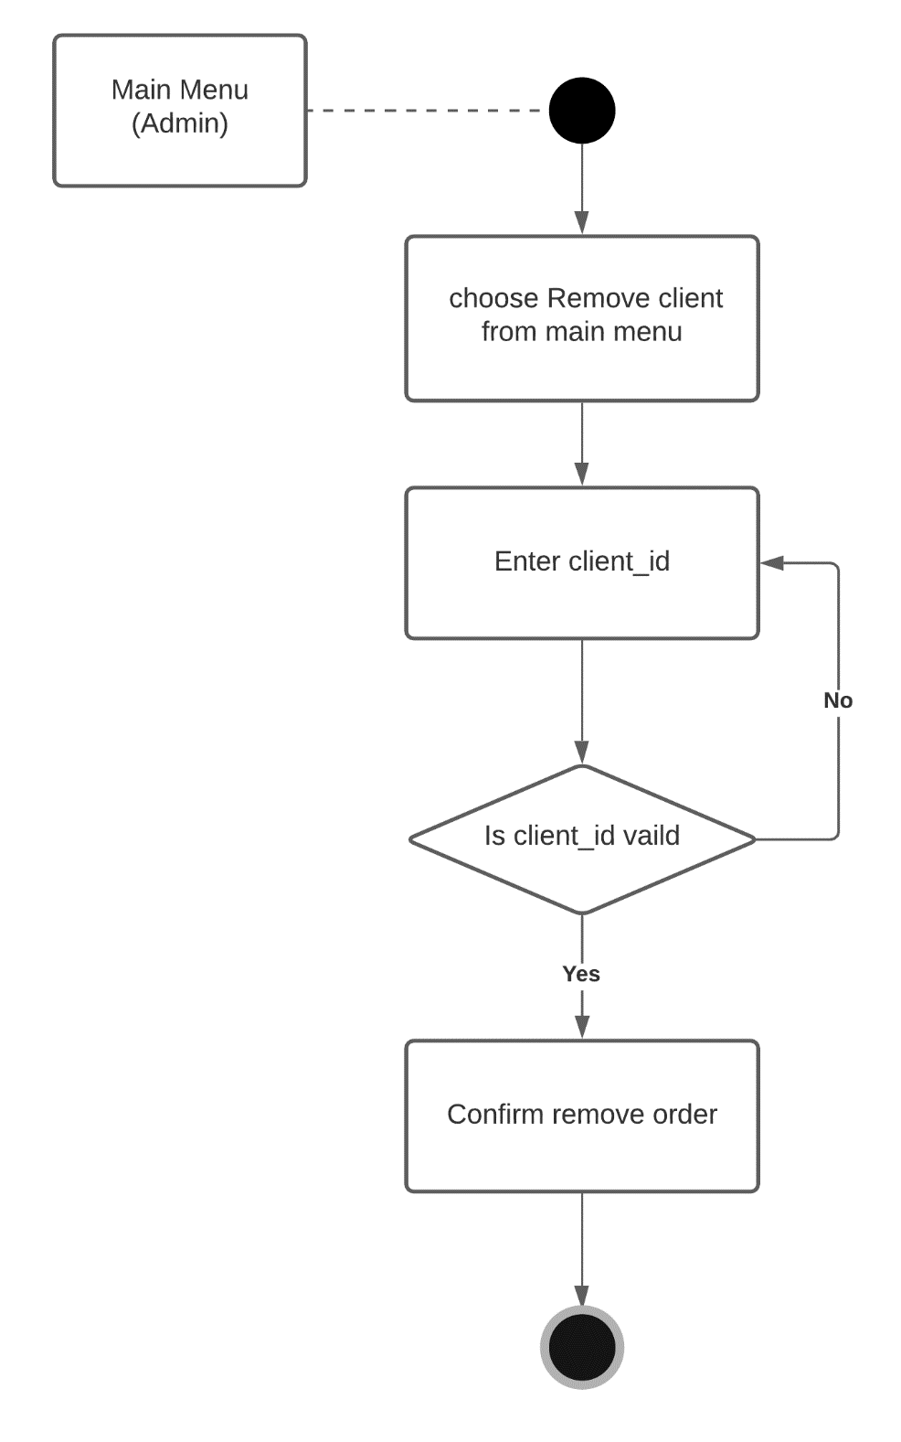

Inquire book

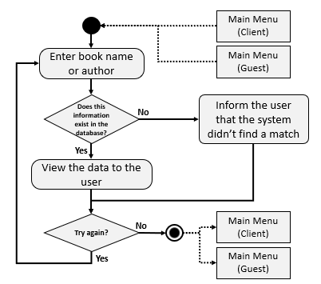
Activity diagram “Inquire about a book”:
Now, let’s get into “Inquire about a book” activity diagram and explain how it works and the logic behind it.
First in order to get to that activity the user has to choose it from the main menu, from there the main menu sends him to the activity from which he is going to start his query, He has the ability to search for a particular book by it’s name or by the name of it’s author or both.
The program then sends to the database asking for the information provided by the guest or client to check if the book exists in the library or not, if the server finds the book in the database then it sends it back to program to view the results to the user, in case it does not find a match for it in the database, the sever sends to the program to inform the user that it did no find a match in the database.
Figure 1: Activity diagram for inquiring about a book.

At the end of the activity it asks the user if he wants to make another inquiry or not, if his answer is yes then the activity starts again from the beginning for him to enter another enquiry, and in case his answer is no, then the program sends him back to the main menu, and with that said, all of the above information can be summed up by the activity diagram shown in Figure 1.

Read book

Activity diagram “Read book”:
In this section we are going to discuss the Read book activity diagram and explain it, same as “inquire about a book” activity diagram this activity gets activated when the user chooses it from the main menu, from there he can choose either search from the book by the book name or by the author of that book same as “Inquire about a book” activity diagram.
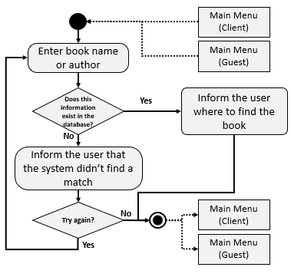
After writing the book name or it’s author and searching for it, the program sends this data to the server to check on it if the book exists in the database or not, then it replies with the answer if it found it or not, if the answer is yes, then the program informs the user where to find the book in the library, and then terminates the activity and sends the user back to the main menu , if the answer is no, then the program informs the user that the system didn’t find a match for his search in the library’s database, in this case the program provides the user with two choices, he can terminate the activity and go back to the main menu, or he can try again and start from the beginning and start entering a different book name or a different author name, and by saying that we conclude that this activity will loop either till the user finds a book he is looking for or he chooses to terminate the activity and go back to the main menu.
Figure 2: "Read book" Activity diagram

Borrow book

Eighth activity is borrow book and it work as:
- Choose borrow book from setting
- Inquiry about available book if book is available then continue
- Else end the activity with sentence “not available”
- Check validate of member if member is valid then continue
- Else end the activity with sentence “not available”
- Check number of issued to member if member has maximum quota exceeded then end the activity.
- Else add new book in the list of member
- Update book status
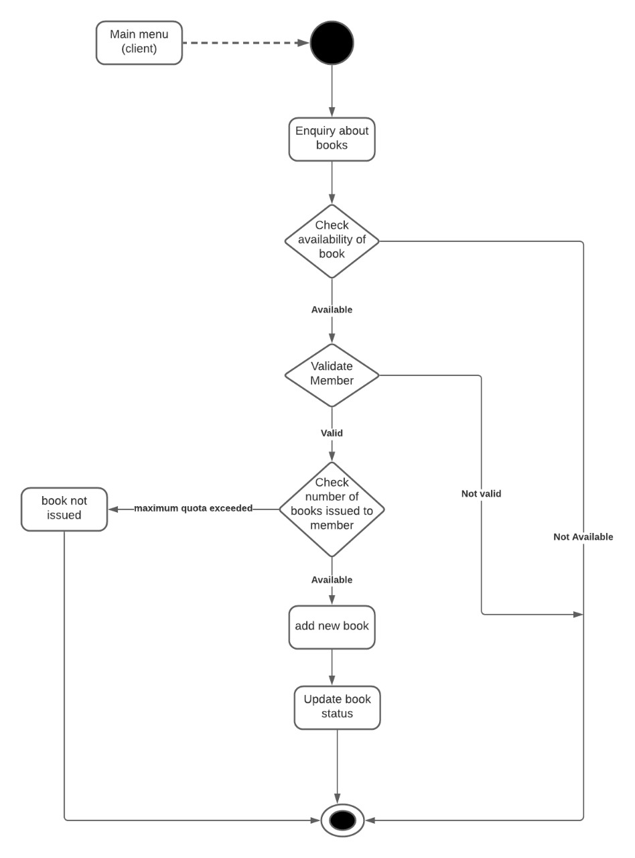

Return book

Ninth activity is return book and it work as:
- Submit the book
- Check book if it is kept within time limit then kept book
- Else pay a fine
- Then update status of book
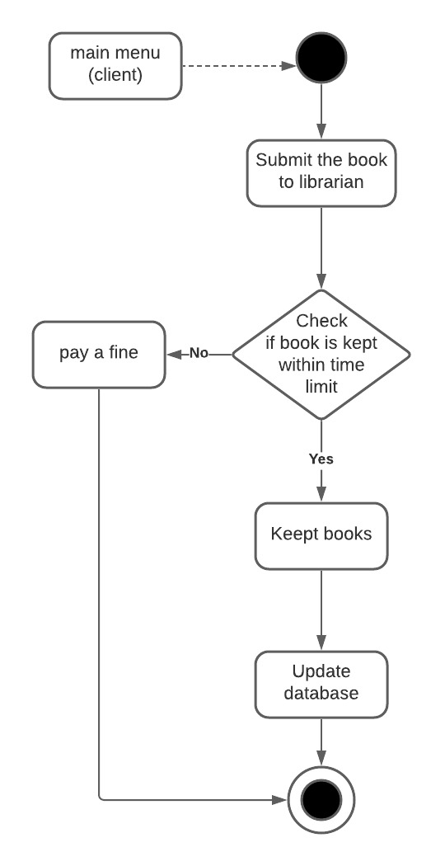

State Diagram

When we start the program, the screen shows 3 Categories:-
      - Login as Admin.
      - Login as Guest.
      - Login as Client.

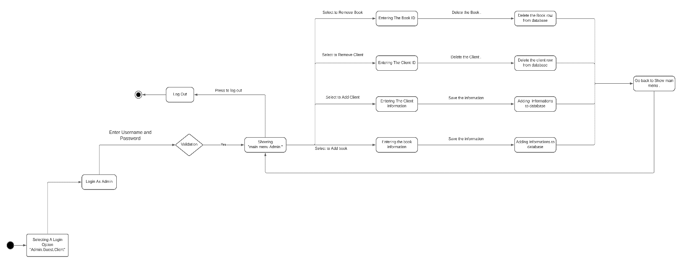

If we select the first one "LogIn As Admin " state then the program asks to enter the Username and Password then it move to Validation step which means checking if the data that user entered is right or wrong then if the condition is right so it shows "Main menu Admin " state that we can select one of the options that allowed for that user so if we select to Add Books we goes to "Entering the Book Information " State after entering that information we have to press Save button so we can move to the next state "Adding Information To the Database " and finally goes back to "Main Menu Admin" to select another option like
Add Clients we goes to "Entering the Client Information " State after entering that information we have to press Save button so we can move to the next state "Adding Information To the Database " and finally goes back to "Main Menu Admin" to select another option like
Remove a client we goes to "Entering the Client ID " State after entering that ID if that client . we have to press Delete button so we can move to the next state "Delete Client row from Database " and finally goes back to "Main Menu Admin" to select another option like Selecting to Remove Books we goes to "Entering the Book ID " State after entering that ID . We have to press Delete button so we can move to the next state "Delete Book Row from Database” and finally goes back to "Main Menu Admin" to select or do whatever you want like Selecting to log out then goes to that state which is called "Log Out " to the end closing the program .

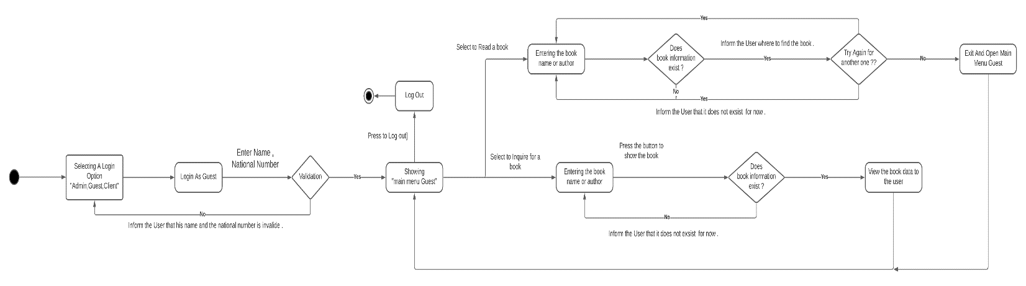

If we select the Second one "LogIn As Guest " state then the program asks to enter the Name and National Number then it move to Validation step which means checking if the data that user entered is right or wrong then if the condition is right that means that data he entered matches in the database so it shows "Main menu Guest " state that we can select one of the options that allowed for that user so if we select to inquire for a book so we move to state "Entering the Book Name or Author" then after we entering that data he asked for we have to press the button to show the book then we goes to the condition that called "Does that book information exist ? "If the answer no that makes the program would inform the User that it doesn't exist for now ,and goes back to "Entering the book Name or Author " if u want to enter another book data ,but if the answer of the condition was yes so we go to the state that called "View the book data to the user " then goes back to "Showing Main Menu Guest " State to choose another option like selecting to Read a Book we goes to state called "Entering the Book Name or Author " then entering the data program asked for , then it goes to the condition "Does Book information exist ? "
If the answer was no makes him to go back to "Entering the Book Name or Author” State to try another book data and inform the user that book doesn't exist for now , but if the answer of the condition was yes . Then inform the user where to find the book, then goes to another condition "Try again for another one? “If the answer was right make him goes back to "Entering the Book Name or Author " State again ,but if the answer was no so goes to another state called "Exit and open Main Menu Guest " then connected to go back to "Showing Main Menu Guest " to select another option like
Selecting to log out then goes to that state which is called “Log Out” to the end closing the program.

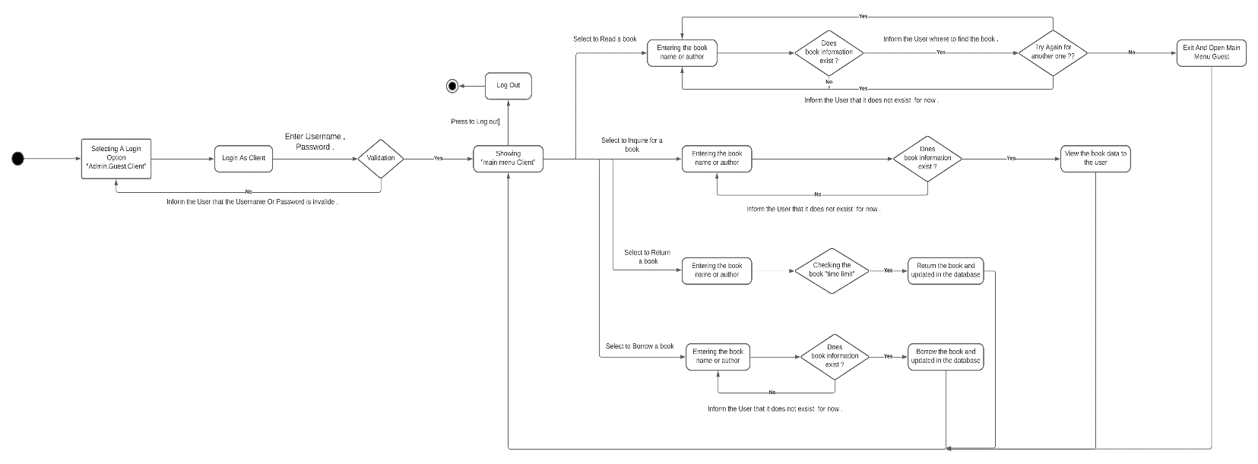
If we select the Third one "LogIn As Client " state then the program asks to enter the Username and Password then it move to Validation step which means checking if the data that user entered is right or wrong then if the condition is right that means that data he entered matches in the database so it shows "Main menu Client " state that we can select one of the options that allowed for that user so if we select to inquire for a book so we move to state "Entering the Book Name or Author" then after we entering that data he asked for we have to press the button to show the book then we goes to the condition that called "Does that book information exist ? "If the answer no that makes the program would inform the User that it doesn't exist for now , And goes back to "Entering the book Name or Author " if u want to enter another book data ,but if the answer of the condition was yes so we go to the state that called "View the book data to the user " then goes back to "Showing Main Menu Client " State to choose another option like selecting to Read a Book we goes to state called "Entering the Book Name or Author " then entering the data program asked for , then it goes to the condition "Does Book information exist ? "
If the answer was no makes him to go back to "Entering the Book Name or Author” State to try another book data and inform the user that book doesn't exist for now , but if the answer of the condition was yes . Then inform the user where to find the book, then goes to another condition "Try again for another one? “If the answer was right make him goes back to "Entering the Book Name or Author " State again ,but if the answer was no so goes to another state called "Exit and open Main Menu Client " then connected to go back to "Showing Main Menu Client " to select another option like
Borrow a Book we goes to state called "Entering the Book Name or Author " then entering the data program asked for , then it goes to the condition "Does Book information exist ? " . If the answer was no makes him to go back to "Entering the Book Name or Author” State to try another book data and inform the user that book doesn't exist for now , but if the answer of the condition was yes . Then inform the user where to find the book and goes to next State called "Borrow the Book and update the database. “then go back to the "Showing Main Menu Client" to choose to select another option like Return a Book we goes to state called "Entering the Book Name or Author " then entering the data program asked for , then it goes to the condition "Checking the book time limit " . If the answer was yes. Then inform the user where to return the book and goes to next State called "Return the Book and update the database. “Then go back to the "Showing Main Menu Client" to choose to select another option like Selecting to log out then goes to that state which is called ”Log Out " to the end closing the program .

Sequence Diagram
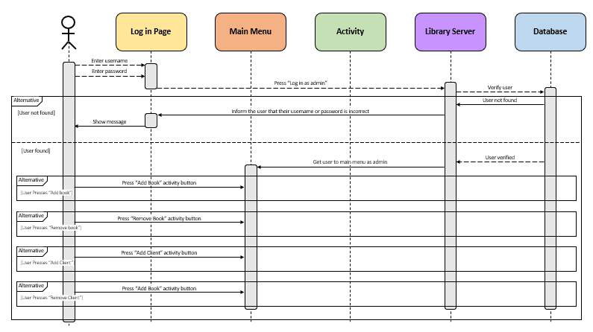
Figure 3: Sequence Diagram
The Sequence diagram is an important diagram from which we get to know the time it takes an activity or an operation to be executed on the different layers of the whole system, and it gives a greater view of the functions and activities that the developers are going to develop and every step they have to consider, using that knowledge to modify the components of the system hardware and software to the projects’ needs and guide the developers through the development process.
As we see in Figure 3, the user is going to enter his username and password first then chooses whether he wants to enter the system as an administrator, guest or a client sending this data to the library server to be verified from the library’s database.
In case that the system could not find a match for the data provided by the user in the database, it answers with “user not found” to the library server, from there the server sends a message to the login page to inform the user that he has entered a wrong username or password by showing a message on the screen, otherwise the system finds the username and password in the database, which tells the server that the data has been found and the user is verified, the server then activates the main menu for the mode that the user chose in the beginning whether a main menu for administrators, guest or a client as each one of these will have special options to choose from depending on the type of the user.
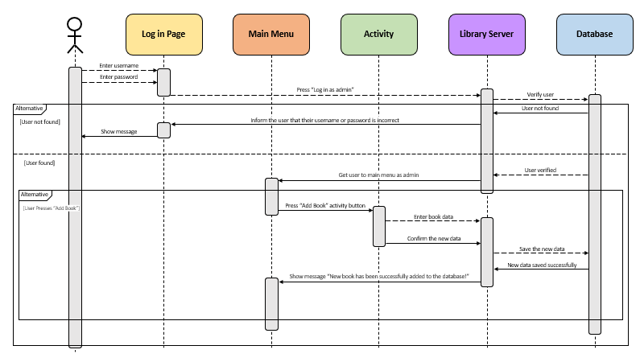
Figure 4: Sequence Diagram (Add book)
Sequence diagram (Add book):
As we discussed in the previous section, the server is going to activate the main menu depending on type of the user from here we can talk about how the “Add book” activity is going to be implemented in the sequence diagram keeping in mind that the only type of user allowed to add books to the library’s database is the administrator.
The activity is going to be activated when the administrator clicks on “Add book” button from the main menu, from there the administrator can enter the new book’s data to the server and then confirm it making the server send the data to the database to be saved and from here the activity window closes, when the server receives the message that the data has been successfully saved from the database, it sends the administrator back to the main menu with a pop up message telling him that the new book has been successfully added to the database.
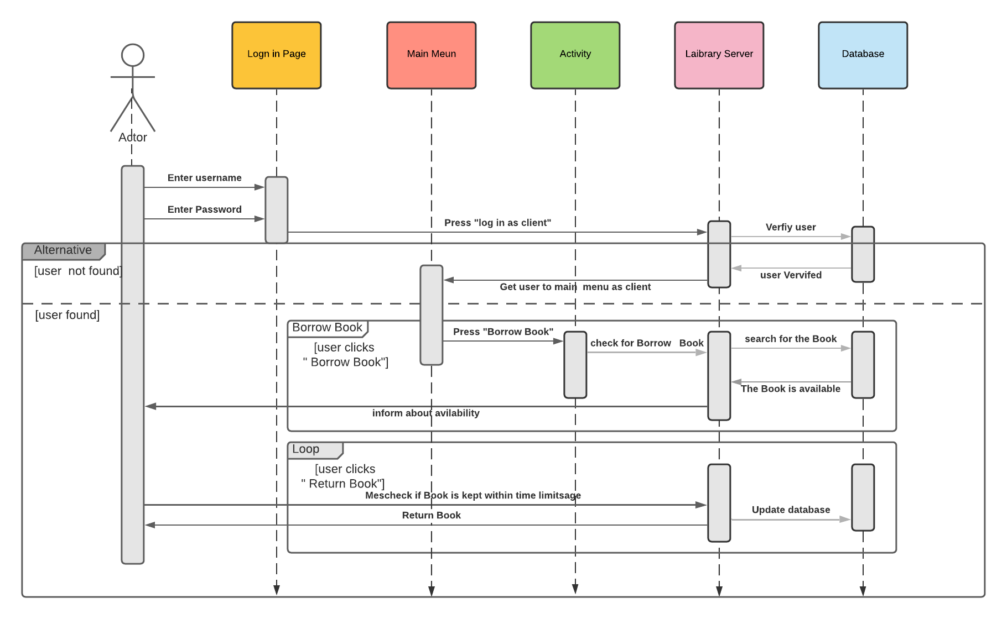
The sequence diagram is a good diagram to use to document a system's requirements and to flush out a system's design. The reason the sequence diagram is so useful is that it shows the system in the time order that the interactions.

Many different commands and queries may need the same arguments. For example, the customer ID may be necessary to perform many subsequent operations. At this point, the designer must decide if the controller must have transient memory for storing these arguments (stateful strategy) or if it is not provided with memory (stateless strategy).

In the stateless strategy, each time a system query or command needs an argument it has to receive it explicitly from the interface. The user will first enter their user name and password and then choose whether to enter the system as an administrator, guest, or client sending this data to the library server for verification of the library database. If the system cannot find a match for the data provided by the user in the database, it answers the library server with "No user found", from which the server sends a message to the login page informing the user that
They have entered the wrong user name or password by showing a message on the screen. Otherwise, the system finds the user name and password in the database, informing the server that the data has been found and the user has been verified (the server then activates the main menu of the profile initially selected by the user The main list of administrators, guests or customers like each of these will have their own options to choose from depending on the user's type.
First the main menu is activated by the type of user then we can talk about how to loan a book from the library and it is executed in a sequence chart The user activates the system when they press the Book Lend button and the user searches for the book he needs in available books in the library and I have the book he needs available A message will be sent that the book already exists and another book will be taken and placed instead and the user returns to the main menu with the message that the book is loaned from the library

Class Diagram

A class is the description of a set of objects having similar attributes, operations, relationships and behavior, Class diagrams are generally used for conceptual modeling of static view of a software application, and for modeling translating models into programming code in a detailed manner. At time of developing or construction software systems, a class diagram is widely used. They are also used for data modeling. It is used to show classes, relationships among them, interface, association, etc. Class in a class diagram simply is a blueprint of an object. It simply describes and explains different type of objects in system, and different types of relationships that exist between them, as we show in figure[3]

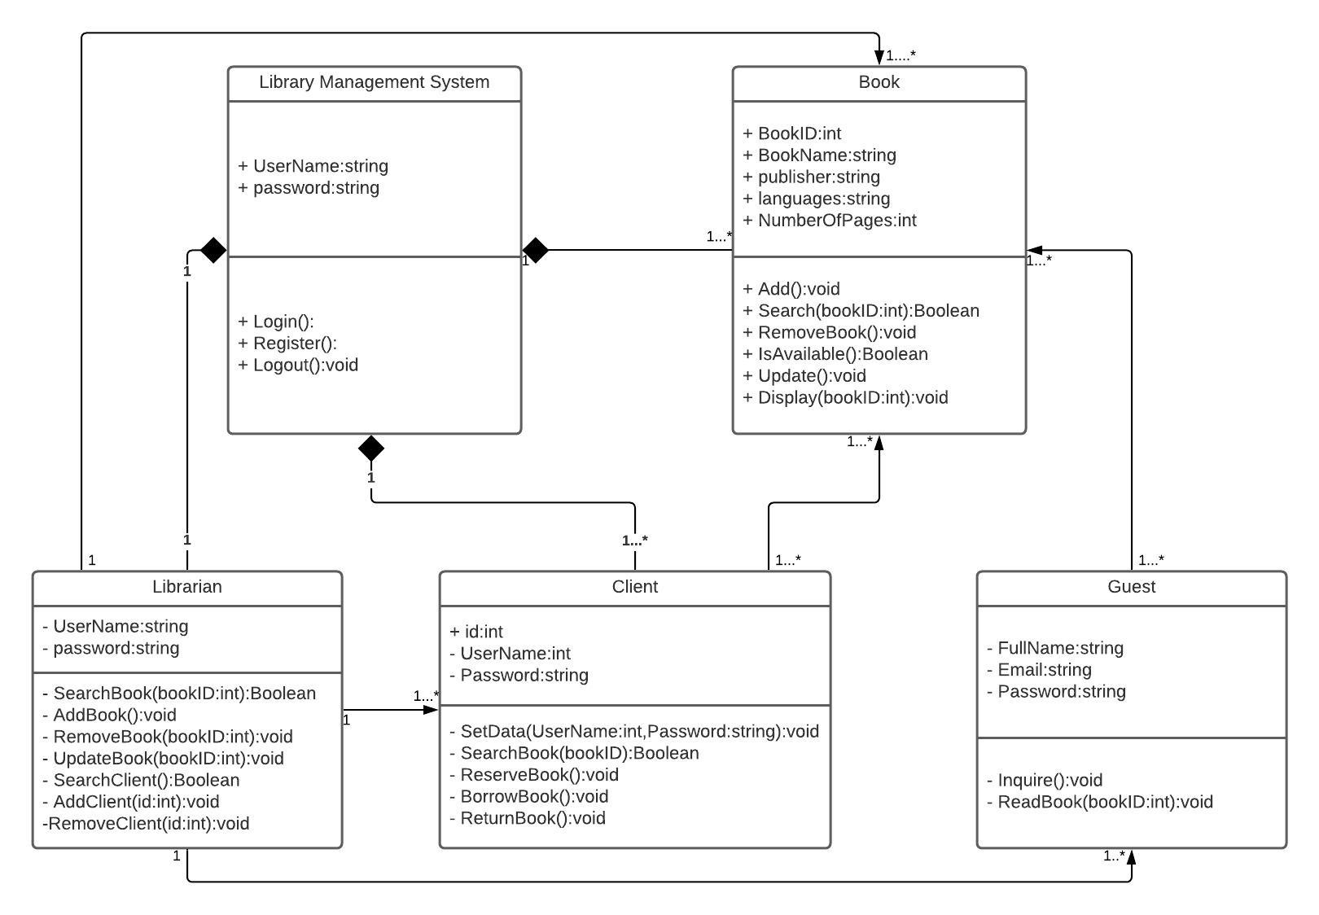
(Figure [3] class diagram)

Classes of Library Management System:
- Library Management System class
It manages all operations of Library Management System. It is central part of organization for which software is being designed.
- Client Class
It manages all operations of client.
- Librarian Class – It manages all operations of Librarian and client, book.
- Book Class
It manages all operations of books. It is basic building block of system.
- Guest Class
It manages all operations of guest.
Attributes of Library Management System:
- Library Management System Attributes –
Username, Password
- Client Attributes –
Name, Id
- Librarian Attributes –
Name, Id, Password
- Book Attributes –
Book name , id, Language, Publisher ,number of pages
- Guest Class Attributes –
Full name, email ,password

Methods of Library Management System:
- Library Management System Methods –
Login(), Register(), Logout()
- Client Methods –
Verify(), Set_data(), search_book() ,reserve_book(),borrow_book(),return_book()
- Librarian Methods –
search_book(),add_book(), remove_book(), search_client(), add_client(), remove_client()
- Book Methods –
search_book(),add_book(), remove_book(), is_available (), update(), display()
Guest Methods –
inquire(), read_book()

Data Flow Diagram (DFD)

Data flow diagram (DFD) is a picture of the movement of data between external entities and the processes and data stores within a system, and provides an indication of how data are transformed as they move through the system. It also depicts the function that transforms the data flow.
Context Data flow (level 0 DFD)
A context data flow diagram (DFD), also known as a level 0 DFD, gives a broad overview of an information system and the way it interacts with external entities. This is presented below figure [1];

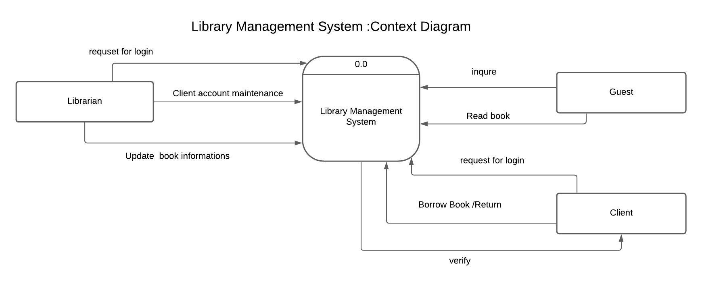
(Figure[1] Context level DFD)
Depicts the flow of information and the transformation applied when a data moves in and out from a system. The overall system is represented and described using input, processing and output in the DFD. The inputs can be:

- Login request when a librarian requests for login to the system.
- Librarian can be access client account and update his information and also can be accept or refuse a guest, can update book information add or remove a book.
- Guest require to enter the system by using email and password, the librarian only who can accept or refuse.
- Guest can only read book from the system.
- Client request for login to the system, he can set his information and update it by using his ID, can borrow book or reserve and return book by using book ID.

Level1 DFD
At this level, the system has to show or exposed with more details of processing.
The processes that are important to be carried out are, The Level 1 DFD outlines how the proposed system is divided into sub-systems (processes), each of which deals with one or more of the data flows to or from an external agent, and which together provide all of the functionality of the system as a whole.
It also identifies internal data stores that must be present in order for the system to do its job, and shows the flow of data between the various parts of the system .The figure[2] below shows the level 1 DFD used for the system;

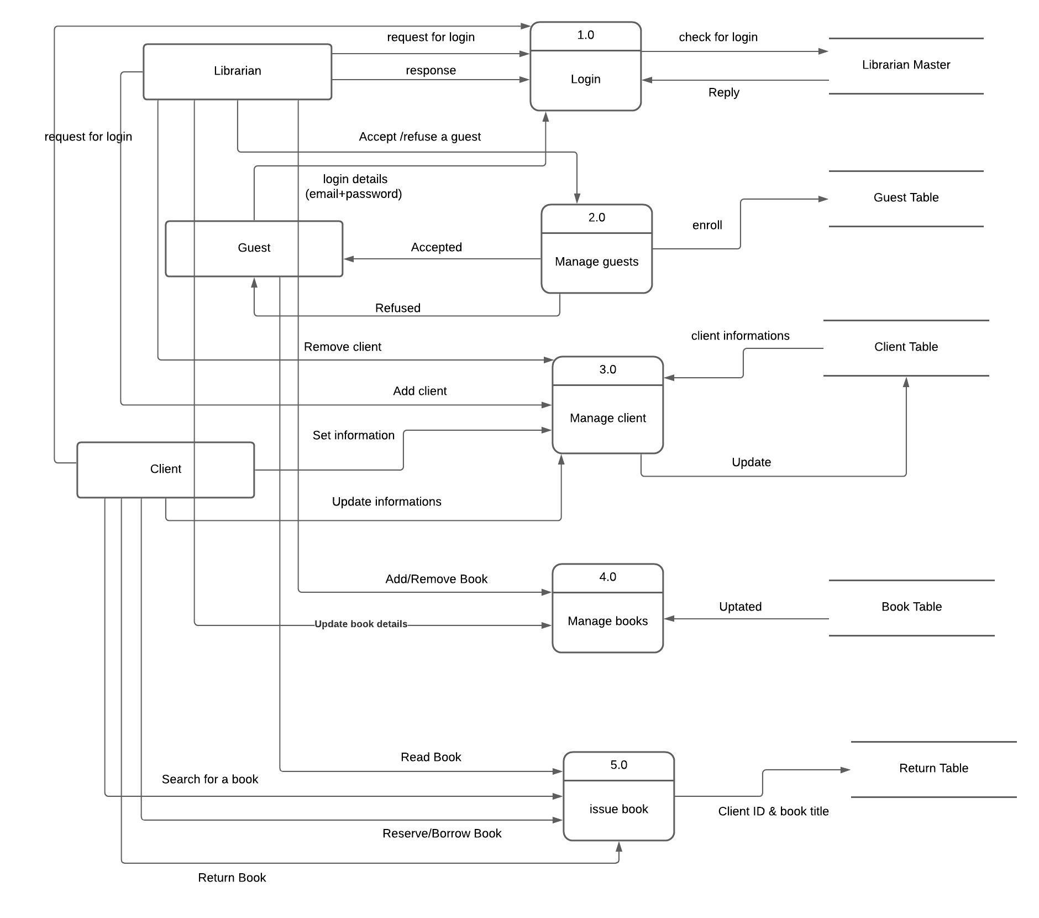
(Figure [2] level1 DFD)

Login procedure:
- Librarian request for login to the system by using password & ID ,system check in master librarian table and reply he can enter the system or not .
- Gest request to enter by using email& password then librarian accept and enroll his information in Guests table or refuse him
- Client request for login by using password, the system check the password and enter if it correct and refuse if not correct.
Manage guest procedure:
- Librarian can accept or refuse the guest.
- If the librarian accept, the system will enroll guest and write his information on guest table and reply “accepted”, if not the system will reply “refused”.
Manage client procedure:
- Librarian can add client or remove client by client ID.
- Client can set his information and can update on it, then the system will add this on client table.
Manage books procedure:
- Librarian can add book or remove book and update book information by book ID.
- After librarian finish, update the system will write updates on book table.
Issue book procedure:
- Guest can only read a book from the system.
Client can search for a book by using book ID and title book, also can reserve or borrow book and return it, the system will write it in return table.

Conclusion

The Library management system needs to be computerized to reduce human errors and to increase the efficiency. The proposed Library management system in this proposal will be a computerized management system developed to maintain all the daily work of library.

Library management systems are designed to store all the information about books and members. The focus of this project is to lessen human effort and encourage efficient record keeping.

The main objective of the Project on Library Management System is to manage the details of Student, Books, Issues, Librarian, and Member. It manages all the information about Student, Address, Member, and Student. The project is totally built at administrative end and thus only the administrator is guaranteed the access.
The purpose of the project is to build an application program to reduce the manual work for managing the Student, Books, Address, and Issues. It tracks all the details about the Issues, Librarian, and Member.

